Project Design Phase-II
Data Flow Diagram & User Stories

Date | 29 June 2026
Team ID
Project Name | ONLINE COMPLAINT REGISTRATION
Maximum Marks | 4 Marks

Data Flow Diagrams:
A Data Flow Diagram (DFD) is a traditional visual representation of the information flows within a system. A neat and clear DFD can depict the right amount of the system requirement graphically. It shows how data enters and leaves the system, what changes the information, and where data is stored.
Example: DFD Level 0 (Industry Standard)
Data Flow Diagram - ResolveHub (Online Complaint Registration)
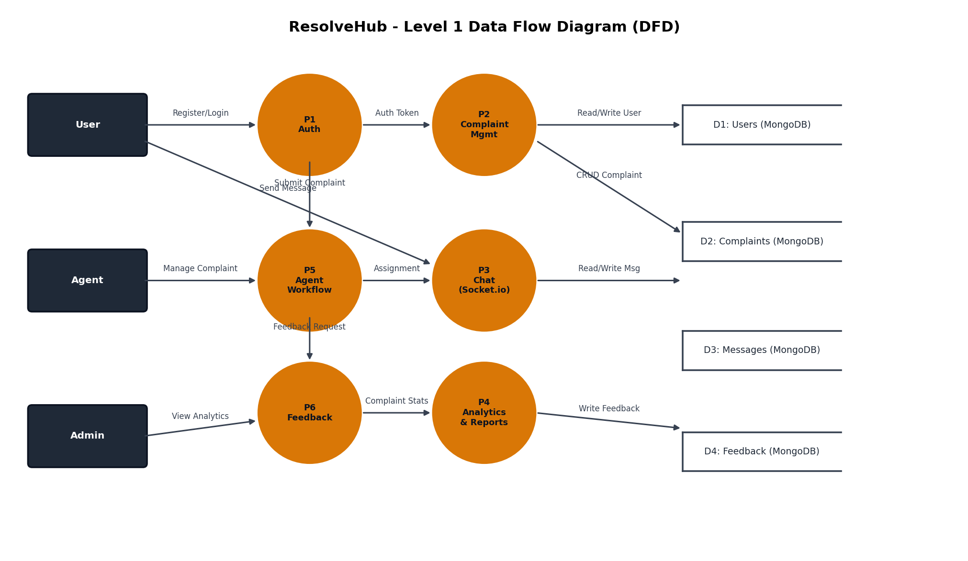
Example: (Simplified)
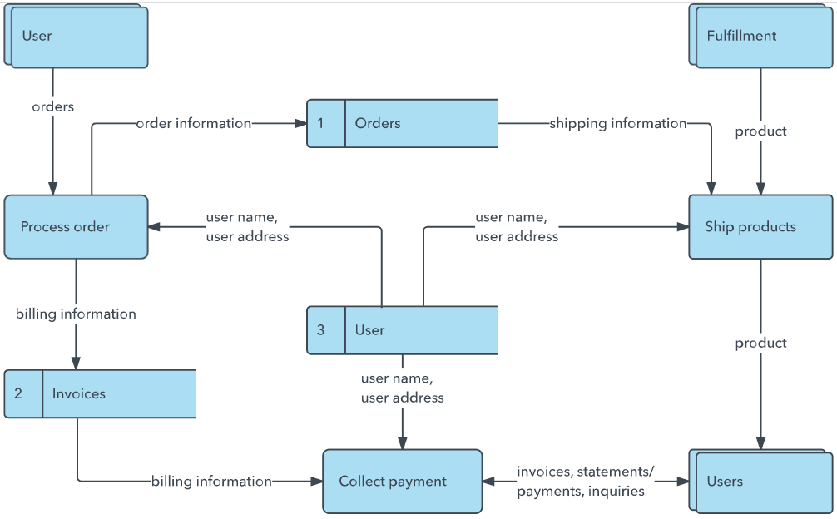


User Stories
Use the below template to list all the user stories for the product.
User Type | Functional Requirement (Epic) | User Story Number | User Story / Task | Acceptance criteria | Priority | Release
User | Registration & Login | USN-1 | As a user, I can register by entering my name, email, password, and selecting my role (USER or AGENT). | Account is created and I am redirected to my dashboard | High | Sprint-1
User |  | USN-2 | As a user, I can log in with my email and password and receive a JWT token for authenticated access. | I am authenticated and redirected to my role-specific dashboard | High | Sprint-1
User |  | USN-3 | As a user, I am blocked from accessing dashboards or routes that belong to other roles. | Unauthorized route access returns a 403 or redirects me to my own dashboard | High | Sprint-1
User | Complaint Management | USN-4 | As a user, I can submit a complaint with title, description, category (Billing/Technical/Delivery/Product/Account) and priority (Low/Medium/High/Critical). | Complaint is created with status PENDING and appears in my complaint list | High | Sprint-2
User |  | USN-5 | As a user, I can view all my submitted complaints and their current statuses. | My complaints list is displayed with real-time status badges | High | Sprint-2
User | Chat | USN-6 | As a user, I can chat in real time with the agent assigned to my complaint. | Messages appear instantly on both sides without page refresh | High | Sprint-3
User | Feedback | USN-7 | As a user, I can submit a rating (1–5) and comment once my complaint is resolved. | Feedback is saved and reflected in admin analytics | High | Sprint-3
Agent | Complaint Resolution | USN-8 | As an agent, I can view all complaints assigned to me from my dashboard. | Only my assigned complaints are visible in my dashboard | High | Sprint-2
Agent |  | USN-9 | As an agent, I can update a complaint status (Assigned → In Progress → Resolved → Closed) and add a resolution note. | Status updates are saved and visible to the user and admin | High | Sprint-2
Agent | Chat | USN-10 | As an agent, I can chat in real time with the user who submitted the complaint. | Messages are delivered instantly via Socket.io | High | Sprint-3
Admin | Agent Assignment | USN-11 | As an admin, I can view all complaints and assign an agent to each one using a dropdown. | Complaint status changes to ASSIGNED and agent name appears in the record | High | Sprint-2
Admin | Analytics | USN-12 | As an admin, I can view a dashboard showing total users, agents, complaints, status distribution (pie chart), and complaints-by-category (bar chart). | Analytics dashboard displays correct aggregated data from MongoDB | High | Sprint-4

